***DATA ANALYTICS WITH COGNOS***

***TOPIC: Product And Scales Analysis***

***Phase 3: Development***

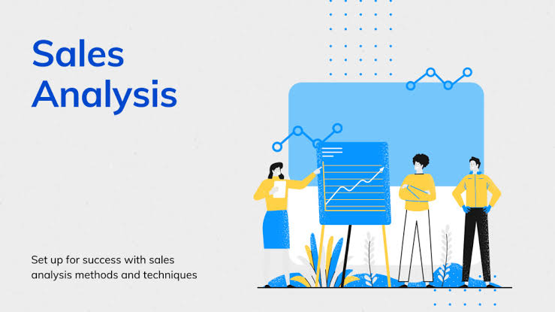

*Objective:*

The objective of this project is to load, preprocess, analyze, and visualize a dataset using IBM Cognos, ultimately creating a comprehensive document for assessment, showcasing the insights and findings derived from the data analysis.

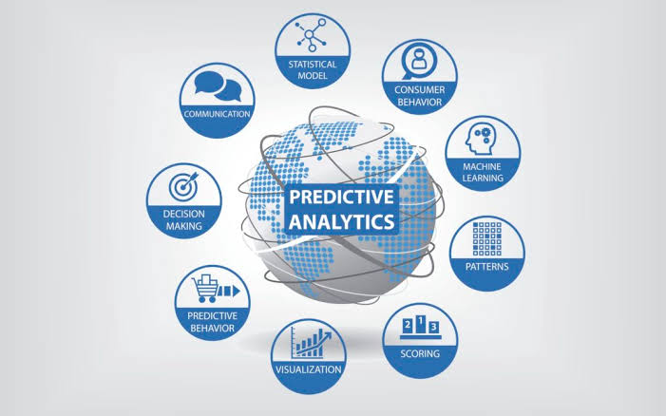

***1. Data Import and Preparation:***

- Import the dataset from Kaggle into IBM Watson Studio.

- Clean and preprocess the data, handling missing values, and data formatting.

*2.* ***Product Development Analysis*:**

- Define your objectives for product development based on the dataset.

- Explore the product sales data to identify trends, popular products, and market demand.

- Develop insights into potential new products or improvements to existing products.

***3. Scale Analysis:***

- Define the scale you want to analyze (e.g., scaling up sales, expanding product lines, or market reach).

- Analyze the dataset to identify areas for scaling, such as regions or products with the highest growth potential.

***4. Statistical Analysis and Visualization*:**

- Use tools in Watson Studio (e.g., Python with libraries like Pandas, Matplotlib, and Seaborn) to perform statistical analysis and create visualizations.

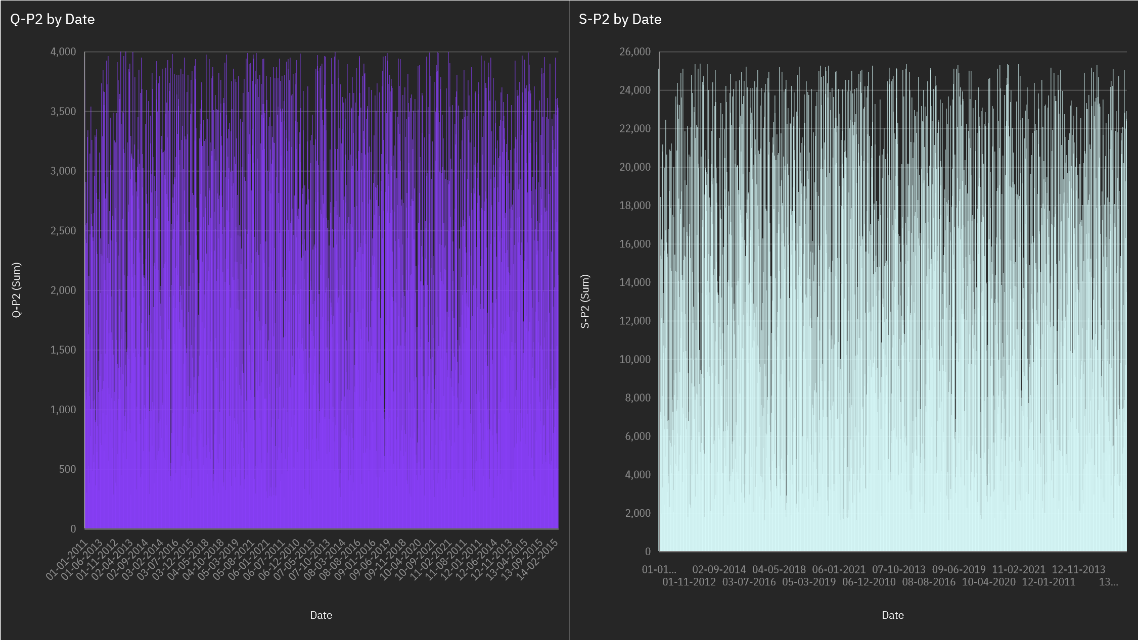

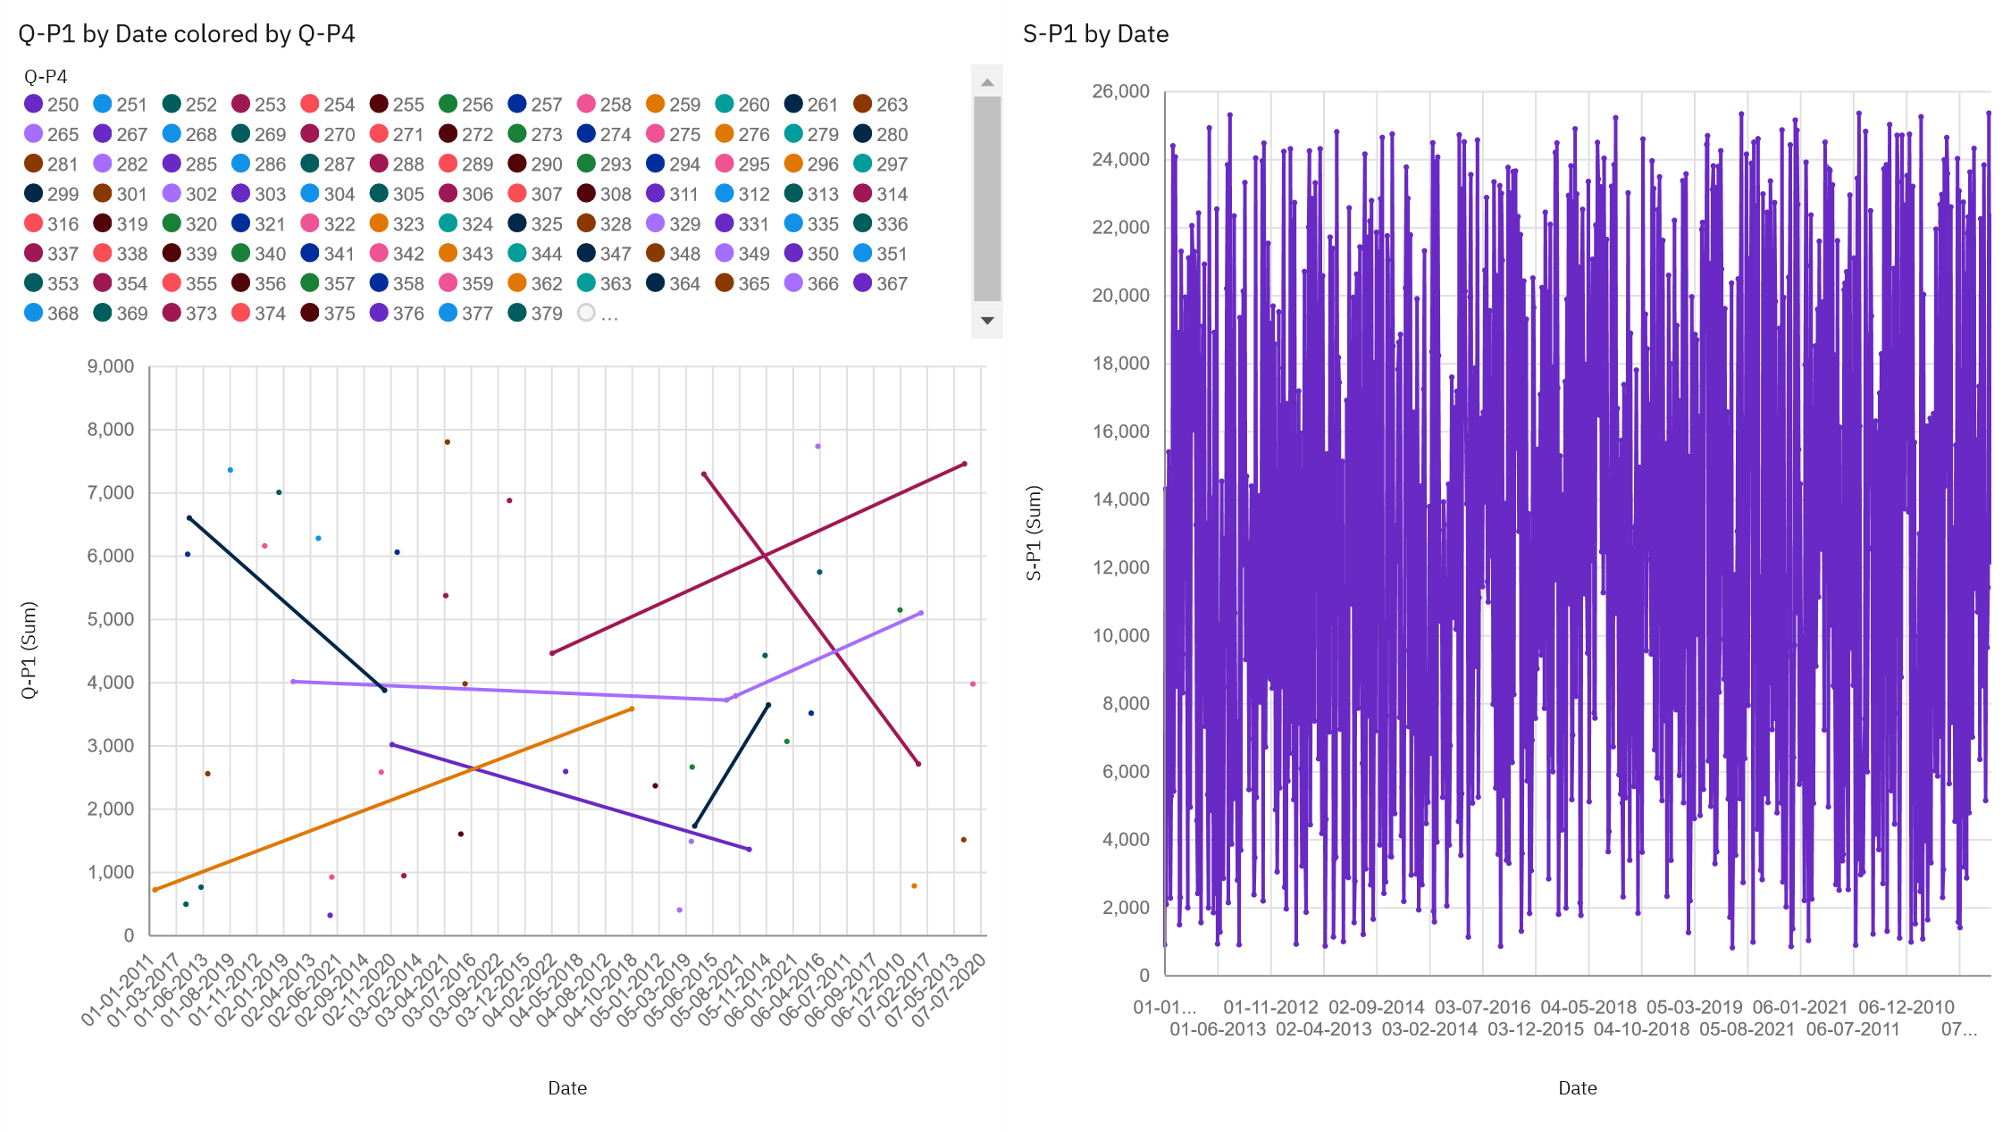

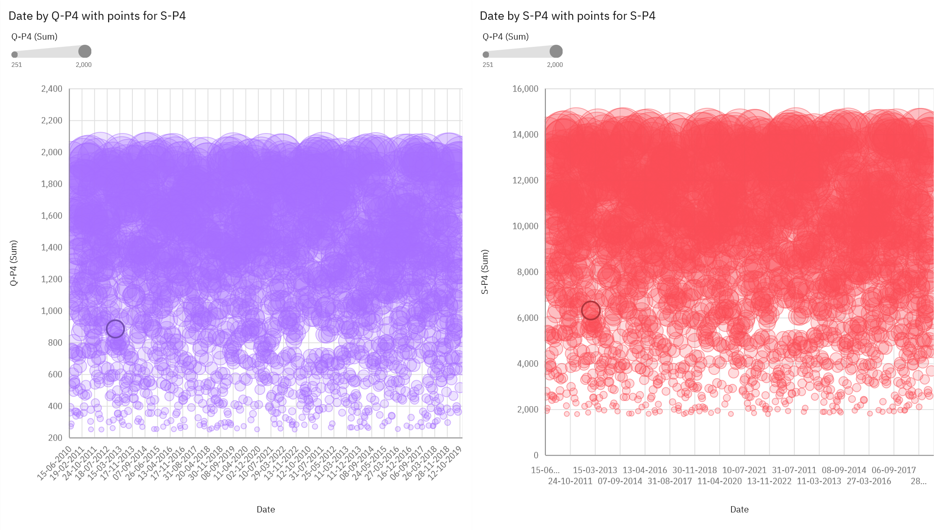

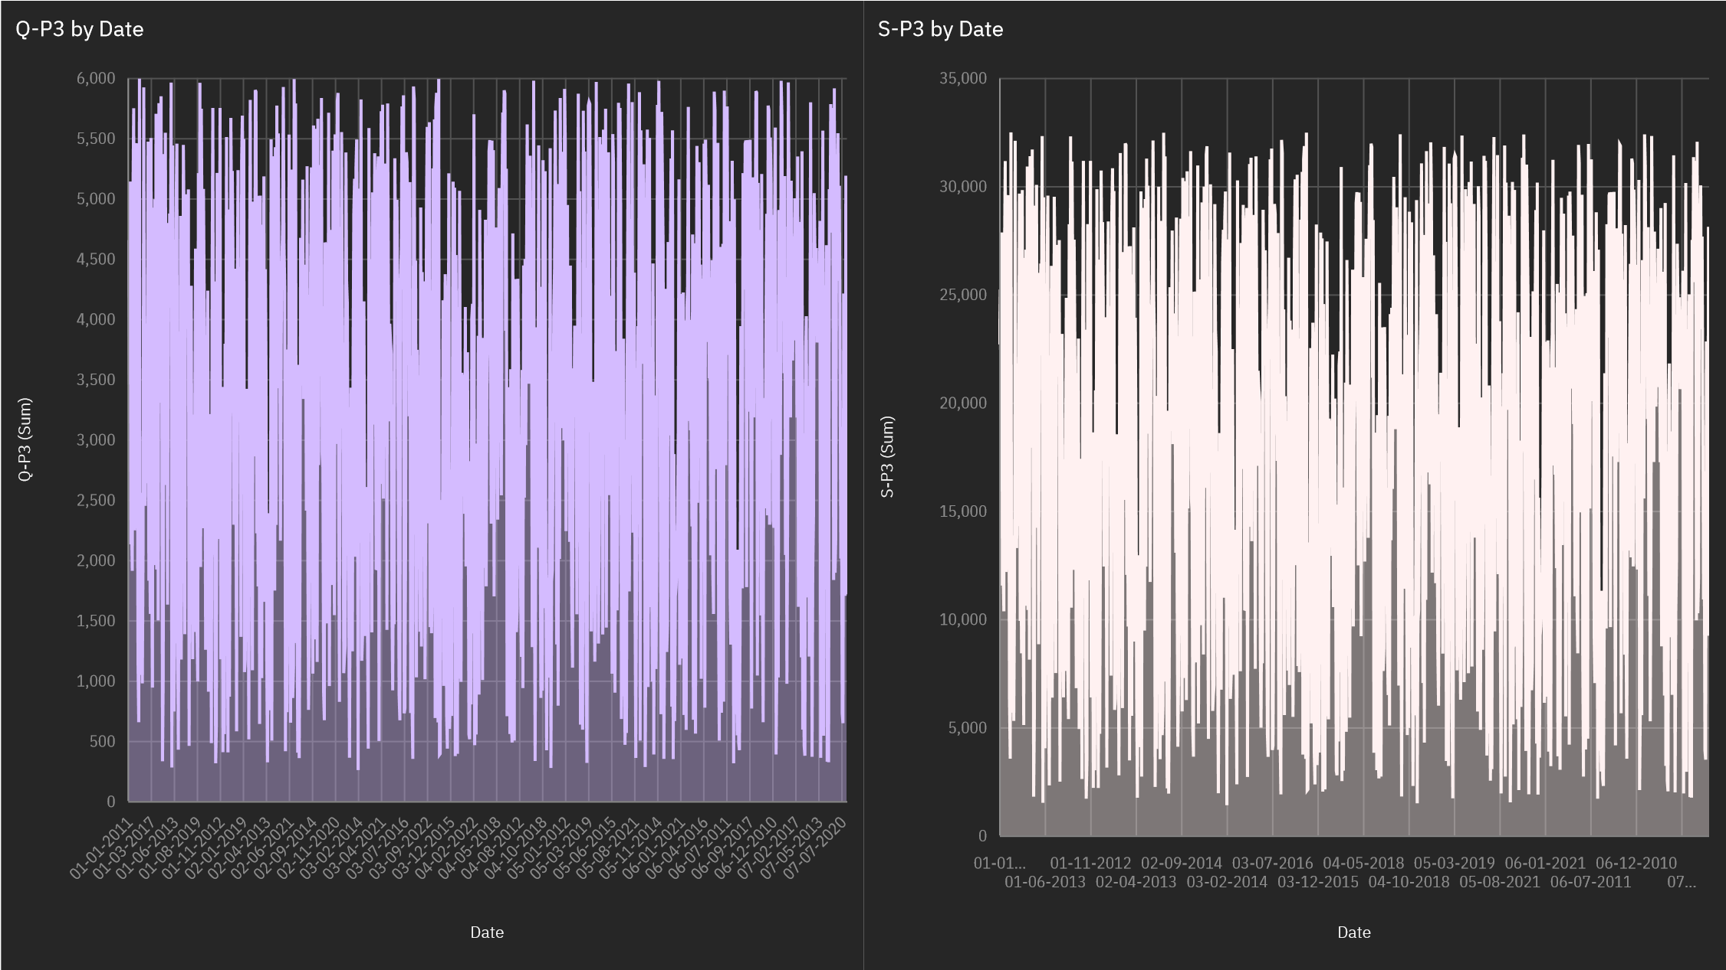

***5. Machine Learning (Optional):***

- If applicable, you can apply machine learning algorithms to predict sales trends or customer behavior.

***6. Report and Presentation:***

- Create a report or presentation summarizing your product development and scale analysis findings.

*```python*

*import pandas as pd*

*# Read the dataset*

*data = pd.read_csv('product-sales-data.csv')*

*# Calculate total sales*

*total_sales = data['Sales'].sum()*

*print("Total sales: $", total_sales)*

*# Calculate average sales*

*average_sales = data['Sales'].mean()*

*print("Average sales: $", average_sales)*

*# Find the top-selling product*

*top_product = data['Product'].value_counts().idxmax()*

*print("Top-selling product:", top_product)*

*# Analyze sales performance over time*

*data['Date'] = pd.to_datetime(data['Date'])*

*data['Year'] = data['Date'].dt.year*

*sales_by_year = data.groupby('Year')['Sales'].sum()*

*print("Sales by year:")*

*print(sales_by_year)*

***Conclusion:***

To draw conclusions from the “Product Scales Data” dataset, we need to consider the specific insights and analysis we aim to drive.

* Scales Trends Over Time.
* Product Perform.
* Summary Statistics.
* Further Analysis.
* Recommendation.